IPO
INPUT | PROCESS | OUTPUT
First number  Second number | - Get the two numbers  - Start with the smallest number as the trial factor  - Repeat: reduce the trial factor by 1 until it divides both numbers exactly  - Show the factor | Highest common factor

FLOWCHART
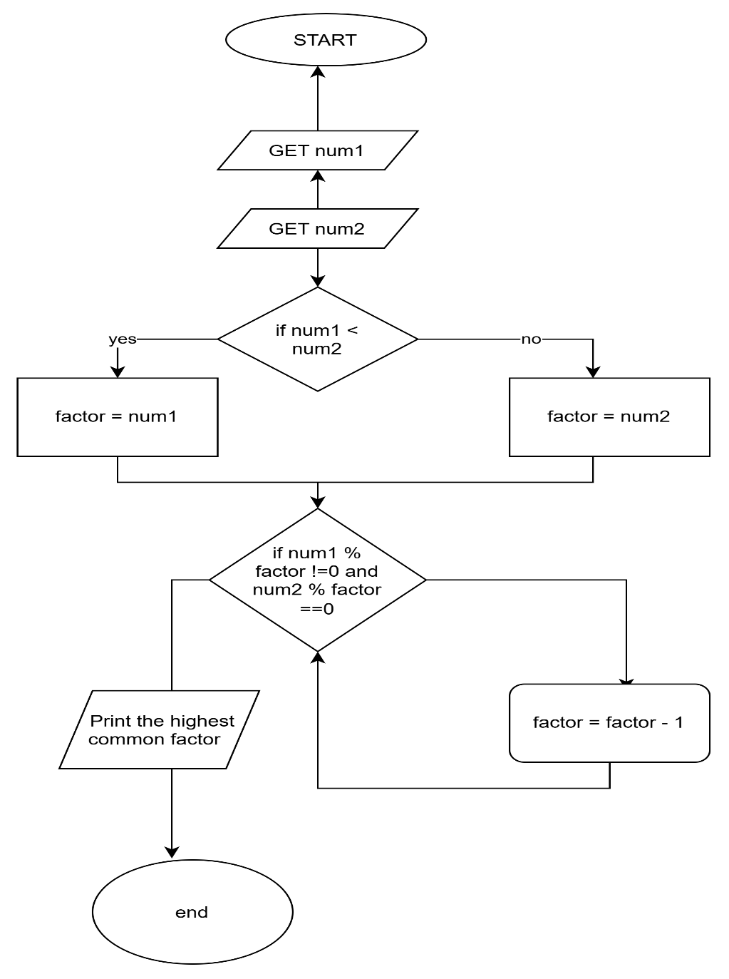

TRACE TABLE
TEST CASE | FIRST | SECOND | EXPECTED RESULT
# 1 | 18 | 12 | 6
# 2 | 6 | 13 | 1 (no common factor except 1)
# 3 | 10 | 10 | 10 (a number and itself)

